Software Requirements Engineering Lab Report

Title:
Software Requirements Specification (SRS) for Online Shopping System

1. Objective
To describe and analyze software requirements using IEEE 830 standards and develop a structured SRS document for an Online Shopping System.

2. Task 1.1: Study of Software Requirements
The IEEE 830 standard defines the guidelines for writing a Software Requirements Specification (SRS) document. It ensures that the requirements are clear, complete, and well-structured.
IEEE 830 helps developers, testers, and stakeholders to understand the system requirements in a standardized format.

🔹 Key Features of IEEE 830
- Provides a standard structure for SRS
- Ensures requirements are:
  - Correct
  - Complete
  - Consistent
  - Unambiguous
- Improves communication between client and developer

3. Task 1.2: Selection of Model & SRS Template
Software Development Model Used: Prototyping Model
Reason: Helps in gathering user feedback and refining UI before development.
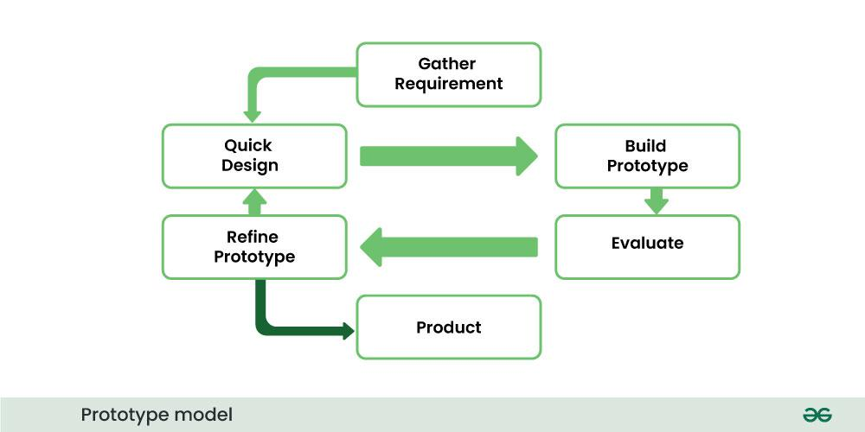
V&V Checkpoints:
- Requirement review
- Design validation
- Testing verification
Outcome:
Structured SRS template prepared.

4. Task 1.3: Requirement Analysis
Stakeholders:
- Customer
- Admin

Requirement Gathering Methods:
- Interview
- Observation
- Questionnaire

Functional Requirements:
- User registration and login
- Product browsing
- Add to cart
- Place order
- Payment system

5. Task 1.4: Verification of Requirements
Verification ensures requirements are:
- Complete
- Correct
- Consistent
- Unambiguous
Tools Used: Git (for version control)

Requirement Verification Table
Requirement ID | Requirement Description | Completeness | Consistency | Clarity | Status
FR1 | User can register | Yes | Yes | Clear | Verified
FR2 | User can login | Yes | Yes | Clear | Verified
FR3 | User can browse products | Yes | Yes | Clear | Verified
FR4 | User can add items to cart | Yes | Yes | Clear | Verified
FR5 | User can place order | Yes | Yes | Clear | Verified
FR6 | User can make payment | Yes | Yes | Clear | Verified

6. Task 1.5: Validation of Requirements
Validation ensures:
- Requirements meet user needs
- Stakeholders approve the system
Steps:
- Present requirements to users
- Collect feedback
- Update document
Outcome:
Validated requirements.

Diagrams

8.1 Use Case Diagram
Actors:
- Customer
- Admin
Customer:
- Register
- Login
- Browse products
- Add to cart
- Place order
- Make payment
Admin:
- Add product
- Update product
- Delete product
- Manage orders

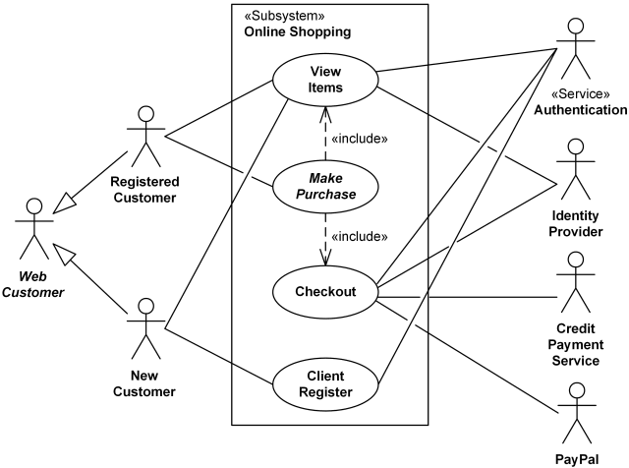

8.2 DFD Level 1
Processes:
- Login/Register
- Product Browsing
- Cart Management
- Order Processing
- Payment
Data Store:
- Database
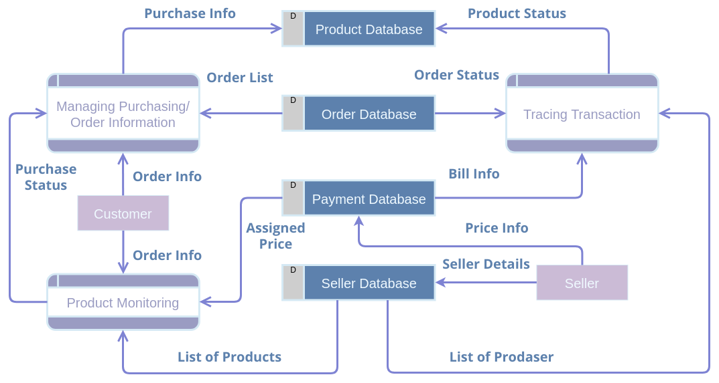

8.3 ER Diagram
Entities:
- User (UserID, Name, Email, Password)
- Product (ProductID, Name, Price, Stock)
- Order (OrderID, UserID, Total)
- Cart (CartID, UserID)
Relationships:
- User places Order
- User has Cart
- Order contains Product
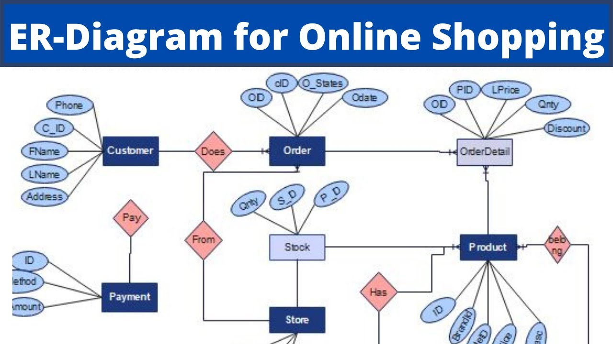

Task 1.6: Version Control
The SRS document is maintained using Git:
- Tracks changes
- Maintains versions
- Ensures traceability

Steps Performed:
- Created a repository in GitHub for the project
- Initialized Git in the local system
- Added SRS document and diagrams
- Committed the files to the repository
- Updated the SRS document after validation and pushed changes

Git Commands Used:

git init
git add .
git commit -m "Initial SRS document"
git branch -M main
git remote add origin <repository_link>
git push -u origin main

git add .
git commit -m "Updated SRS after validation"
git push

9. Conclusion
The experiment helped in understanding how to gather, analyze, verify, and validate software requirements using IEEE standards. A complete SRS document for an Online Shopping System was successfully prepared.
Version control is implemented using Git to manage the SRS document.

